Where条件是对数据库的表中所有行数据的筛选，

Having则是对Group By分组后的全部行数据里，对所有组的筛选、或每个组内成员的筛选；Having的含义类似于Where条件，因此Having后面可以跟着AND、OR、NOT等，就像Where条件那样，但Having只用在Group By之后！

前情数据：

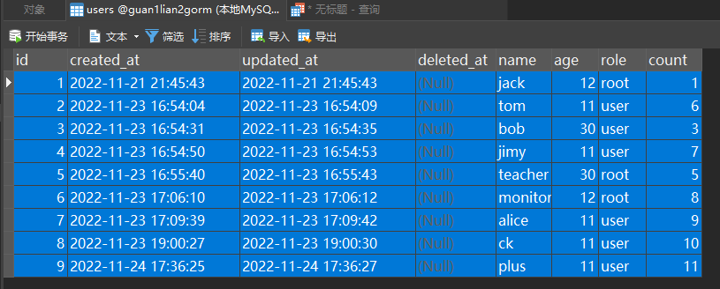

先看看分组后Having前的情况

SELECT * FROM `users` WHERE id < 9 GROUP BY age,id;

（符合预期。而且也可见分组是在Where筛选得到的数据的基础上再分组的）

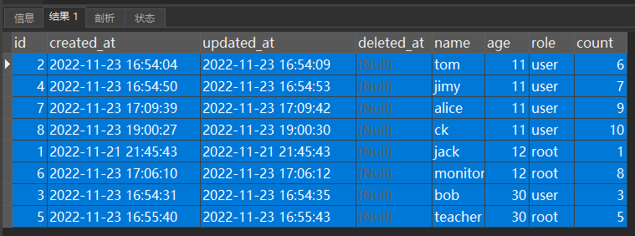

=======================================================================

分组后对组的Having：

SELECT * FROM `users` WHERE id < 9 GROUP BY age,id HAVING age < 30; （符合预期）

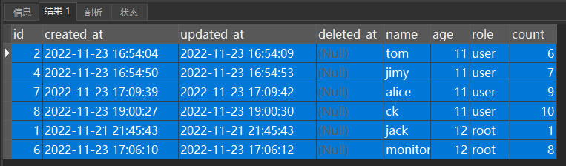

分组后对组的Having：

SELECT * FROM `users` WHERE id < 8 GROUP BY age,id HAVING age < 30; （符合预期）

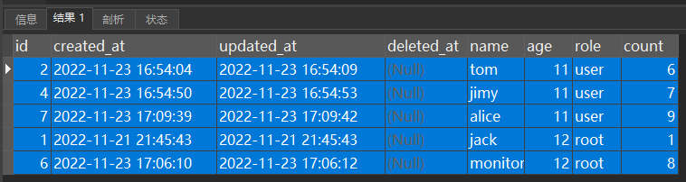

========================================================================

分组后对每个组内成员的Having:

（注意：能对组内成员Having的前提是在分组时每个组已经被撑开，显示出组成员）

SELECT * FROM `users` WHERE id < 9 GROUP BY age, id HAVING `count` > 1;

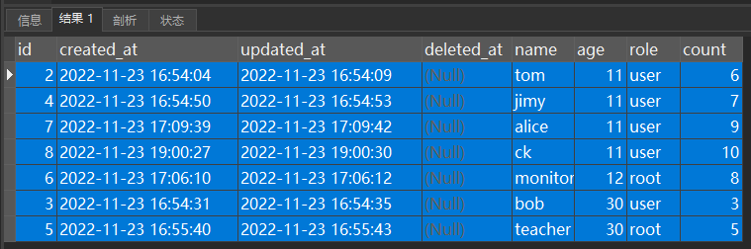

分组后对每个组成员的Having:

SELECT * FROM `users` WHERE id < 9 GROUP BY age,id HAVING role='root';

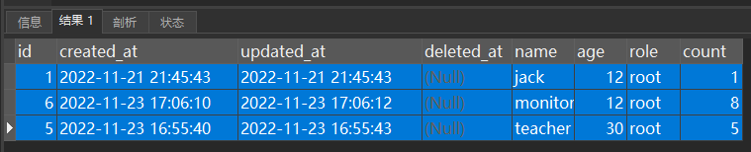

Having的同时ADN或OR或AND NOT的情况

SELECT * FROM `users` WHERE id < 9 GROUP BY age,id HAVING role='root' AND `count`>1;

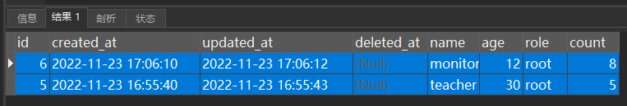

（完）（数据库数据见后面）

CREATE TABLE `users` (

`id` bigint(20) UNSIGNED NOT NULL AUTO_INCREMENT,

`created_at` datetime NULL DEFAULT NULL,

`updated_at` datetime NULL DEFAULT NULL,

`deleted_at` datetime NULL DEFAULT NULL,

`name` longtext CHARACTER SET latin1 COLLATE latin1_swedish_ci NULL,

`age` bigint(20) NULL DEFAULT NULL,

`role` longtext CHARACTER SET latin1 COLLATE latin1_swedish_ci NULL,

`count` bigint(20) NULL DEFAULT NULL,

PRIMARY KEY (`id`) USING BTREE,

UNIQUE INDEX `count`(`count`) USING BTREE,

INDEX `idx_users_deleted_at`(`deleted_at`) USING BTREE

) ENGINE = InnoDB AUTO_INCREMENT = 10 CHARACTER SET = latin1 COLLATE = latin1_swedish_ci ROW_FORMAT = COMPACT;

INSERT INTO `users` VALUES (1, '2022-11-21 21:45:43', '2022-11-21 21:45:43', NULL, 'jack', 12, 'root', 1);

INSERT INTO `users` VALUES (2, '2022-11-23 16:54:04', '2022-11-23 16:54:09', NULL, 'tom', 11, 'user', 6);

INSERT INTO `users` VALUES (3, '2022-11-23 16:54:31', '2022-11-23 16:54:35', NULL, 'bob', 30, 'user', 3);

INSERT INTO `users` VALUES (4, '2022-11-23 16:54:50', '2022-11-23 16:54:53', NULL, 'jimy', 11, 'user', 7);

INSERT INTO `users` VALUES (5, '2022-11-23 16:55:40', '2022-11-23 16:55:43', NULL, 'teacher', 30, 'root', 5);

INSERT INTO `users` VALUES (6, '2022-11-23 17:06:10', '2022-11-23 17:06:12', NULL, 'monitor', 12, 'root', 8);

INSERT INTO `users` VALUES (7, '2022-11-23 17:09:39', '2022-11-23 17:09:42', NULL, 'alice', 11, 'user', 9);

INSERT INTO `users` VALUES (8, '2022-11-23 19:00:27', '2022-11-23 19:00:30', NULL, 'ck', 11, 'user', 10);

INSERT INTO `users` VALUES (9, '2022-11-24 17:36:25', '2022-11-24 17:36:27', NULL, 'plus', 11, 'user', 11);